DATABASE LT-1

1. Select \* from salgrade;

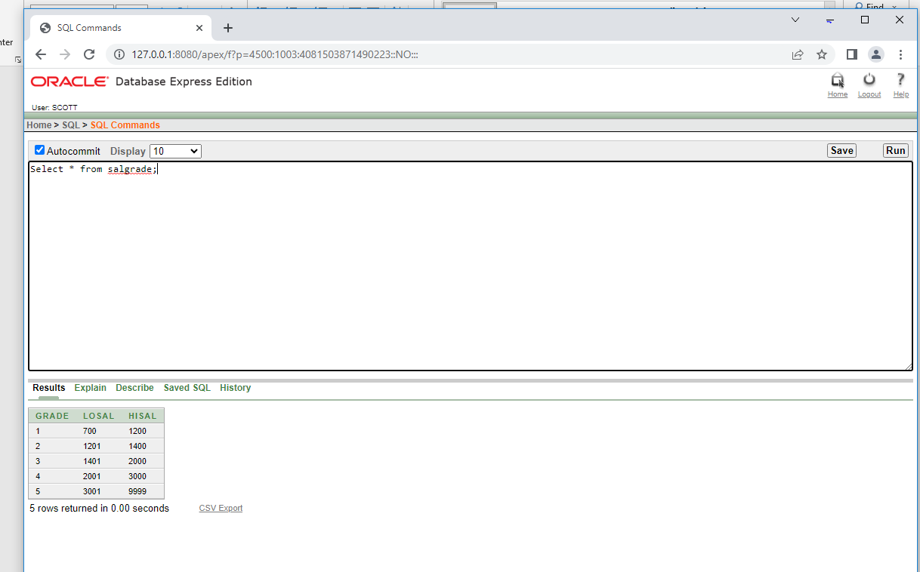

2. Select deptno from dept;

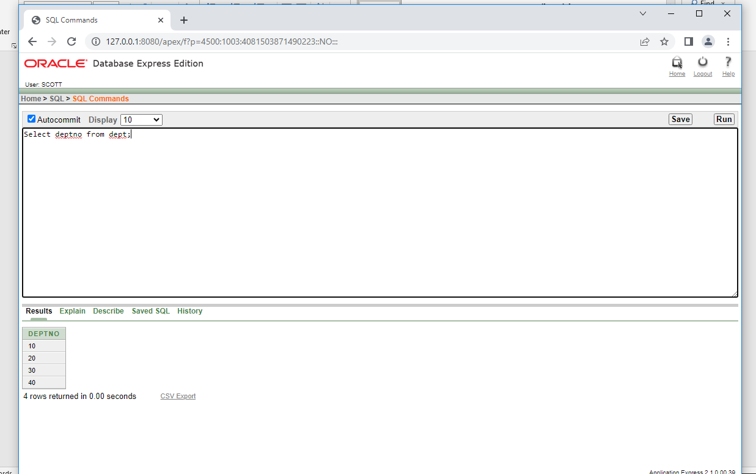

3. Select ename , sal , sal\*0.05 As “Increment sal” from emp;

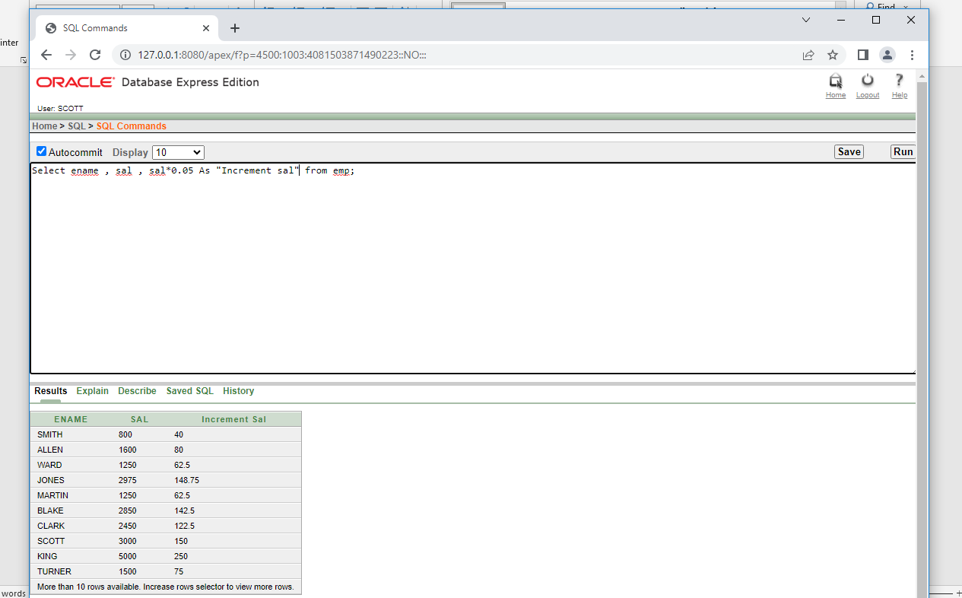

4.Select (sal + sal\*0.05) As “New Salary” from emp;

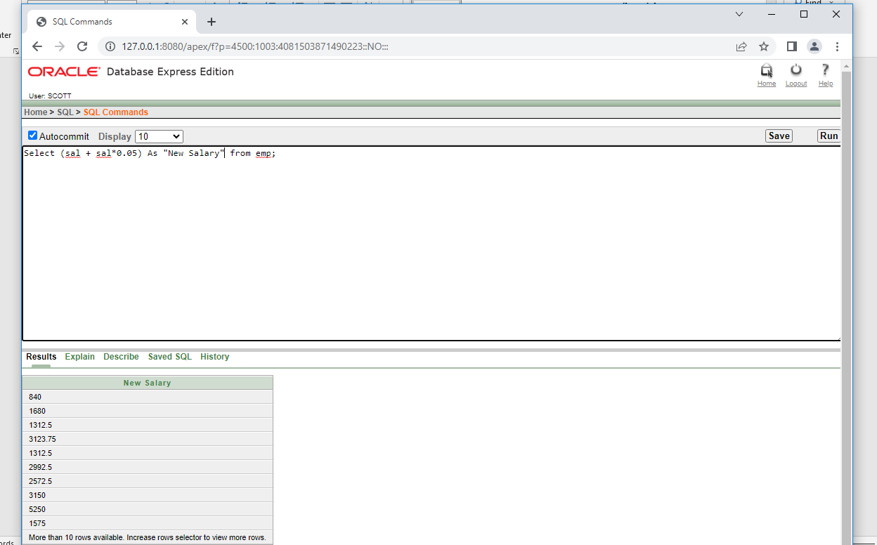

5.select \* from emp where ename= ‘BLAKE”;

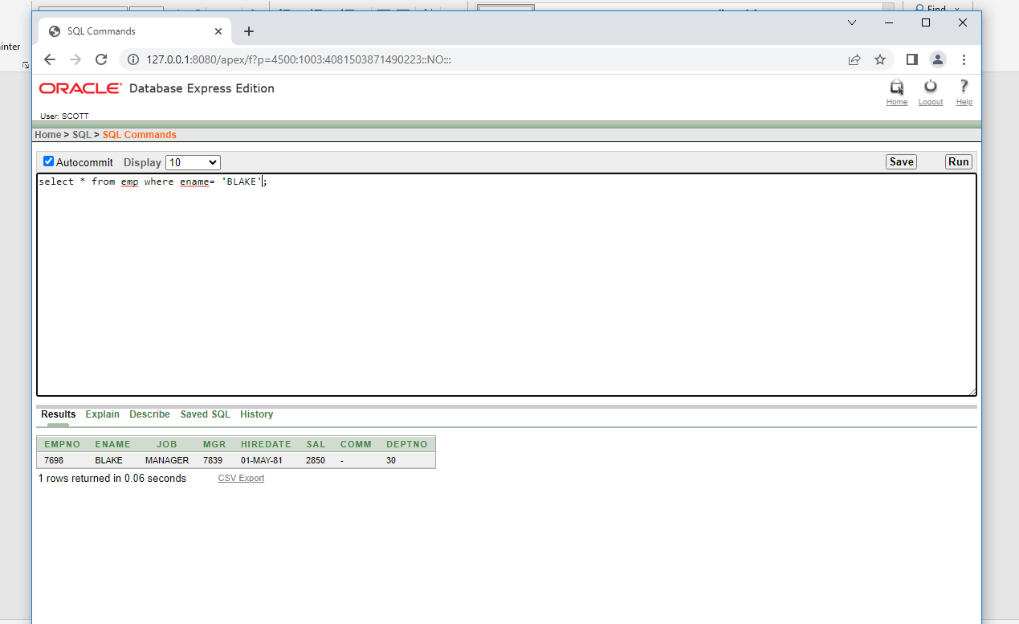

6.Select ename || ‘ is hired on ’ || hiredate || ‘ as a ‘|| job from emp;

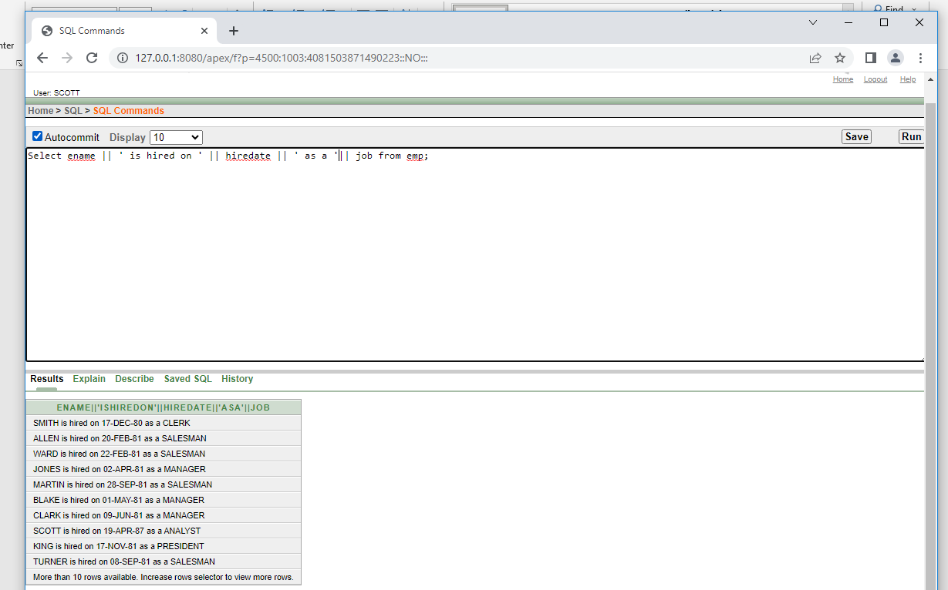

7. Describe emp;

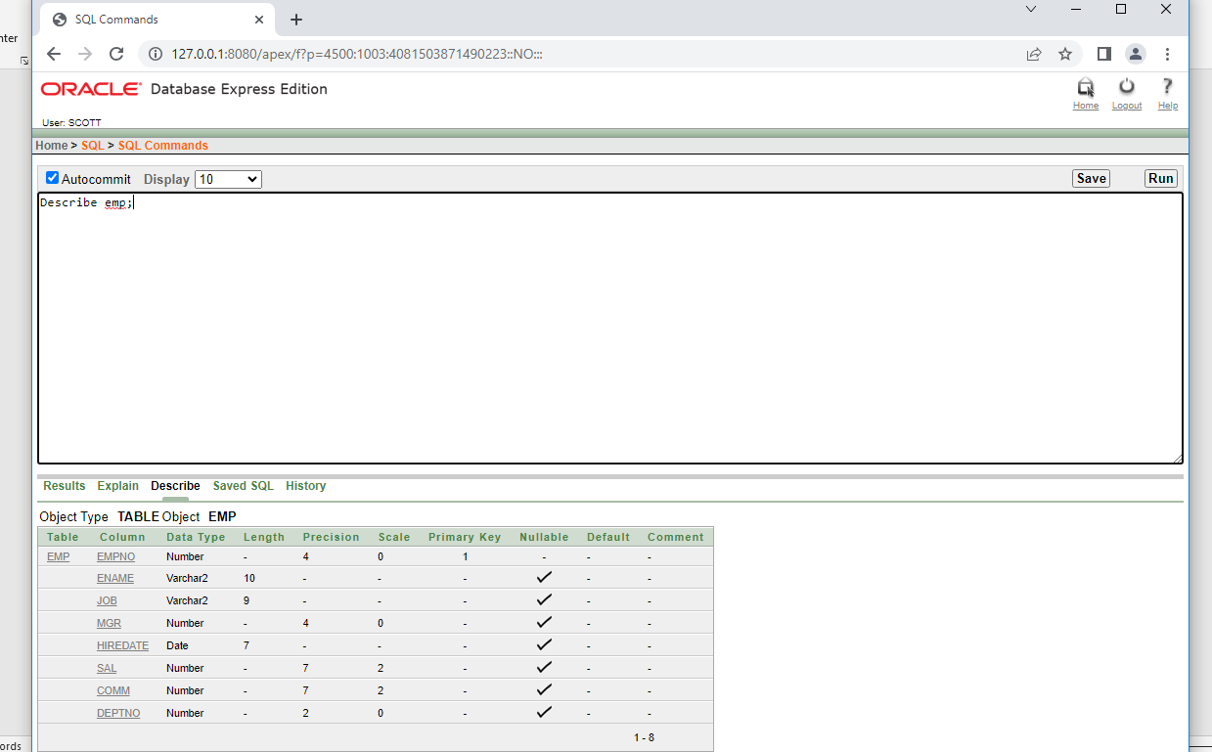

Describe dept;

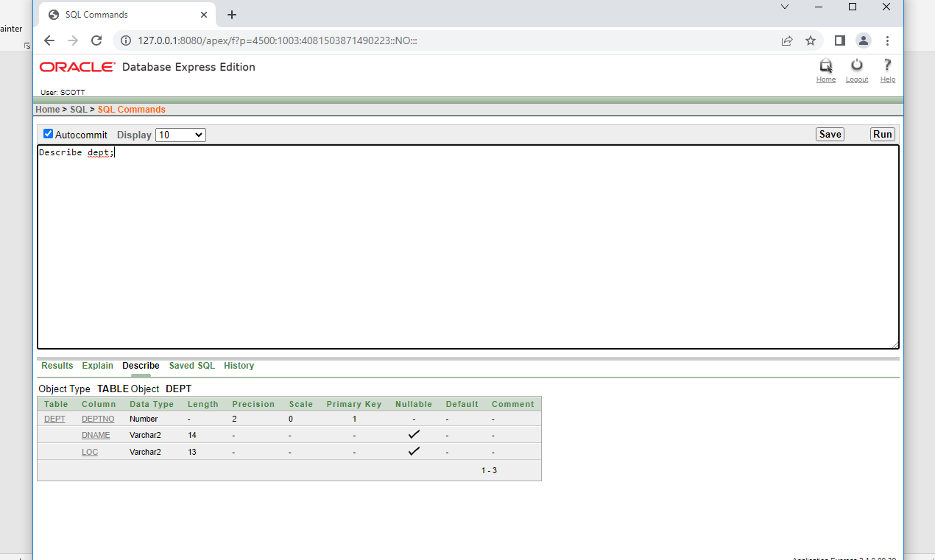

Describe bonus;

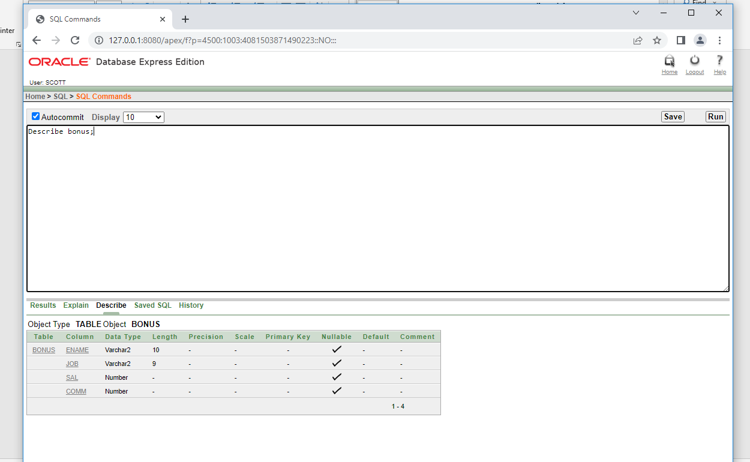

Describe salgrade;

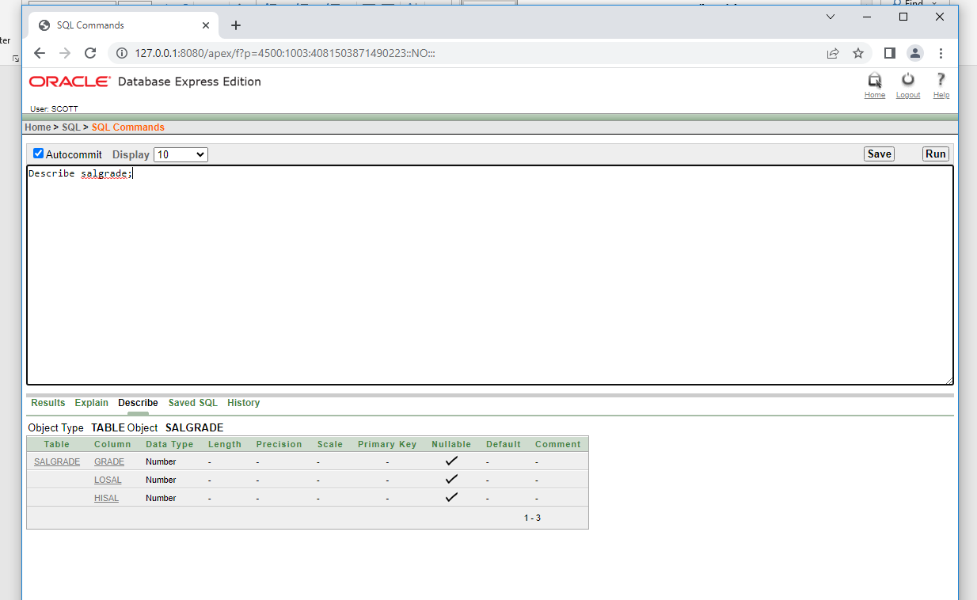

8. Select DISTINCT job from emp;

